a) False

b)hythythythythyt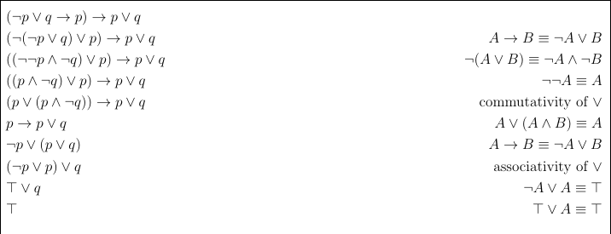

c) box 4-8, and box 9-10 should be side-by-side, but I don’t know how to do that

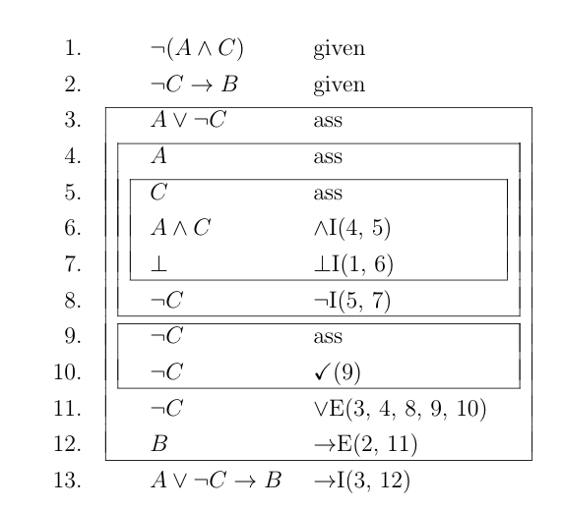

d)

i) A = \*A, \*A = T, \*A = F, [Only table which doesn’t work is \*A = ¬A] (I'm pretty sure \*A=F is wrong) → agree, as writing \*A on a line in ND would be wrong → agree -> agree --> agree-> agree, there is no way \*B can be shown if it's always false -> disagree, since say your givens are ~A, A. Then, you can get F on an ND line, and deduce anything you want from it. So, in this case, your givens are just falsity and some other junk. You can just use the falsity and deduce whatever you want

--------

Maybe a potiential answer -> Not 100% sure!

There are 4 posible truth table values that \* can have which are

A \*A (all true) A \*A (all false)

T T T F

F T F F

A \*A (same) A \*A (not)

T T T F

F F F T

Keeping A the same in \*A would work becuase it is just the reqular implication elemination rule

A (not case ) would not work for sure

The only things to test would be mapping to all true and all false

All true case would work since if A is tt and A -> B is tt which is what we know in ND ( all statements hold), so if B is tt at the end no matter what A is if A -> B is tt ( check using truth table for A -> B) .

By similar reasoning all false case would not work

So the possible truth table for \* are the ones that map to itself and true

-----------

ii) A, and B) I think that’s allowed? Didn’t actually manage to finish writing it down in the exam.

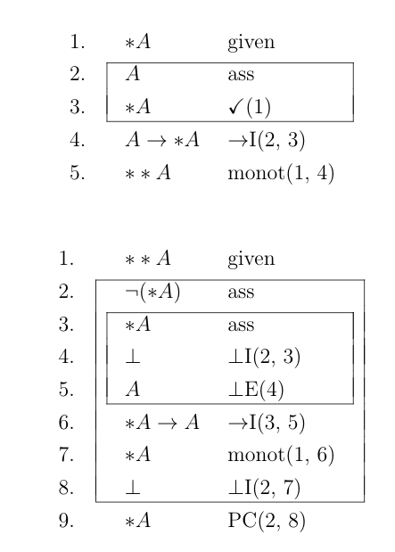Ll;

For B), can use A) to deduce ¬(\*\*A) from line 2, and get the contradiction immediately.

2.

a)

I`````````) 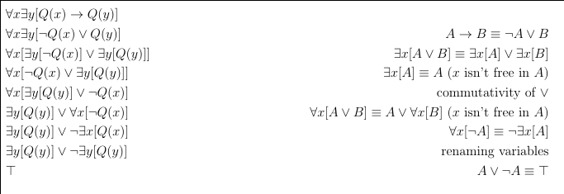

ii) The only case when this is valid is when nothing satisfies Q(x), or everything satisfies Q(x), as this obviously isn’t always true - it’s not valid.

b)a

i) x = 1, 2, 3 ? surely 4 as well as [R(4,4) and R(4,4)] holds. Wait nvm k is a constant

ii) x = 1, 2, 3, 5, 6 ? I don't think 5 works here (Neither do I [i.e. R(6,5) -> S(6) is not true). I dont think 1 works either as nothing points to it [ah its forall so its fine]

iii) x = 3, 4, 5, 6 ? surely 1 and 2 should also work. no : 1 and 2 point to 2 separate objects. I think yes because z can be itself or any other object -> agree

It is at most pointing to itself and one other object(so can only be 3, 4 , 5, 6).

iv) x = ~~1, 2, 3, 5, 6~~ 1,2,4,6 ? I don't think 3 works here, 4 does, 5 doesn’t either (seconded) (pretty sure it’s 1, 2, 4, 6) I agree; I also agree, 1,2,4,6

v) x = 2, 4, 5, 6 ? i don’t think 5 or 6 work here (I think 5 and 6 do). I agree with 2, 4, 5, 6. Me too. Don’t think 5 or 6 works :( [I think 5 and 6 do work, as they each only point to one another] -> I agree with the last bit

5 and 6 don’t work because of 2 and 3 respectively

Why would 1 not work

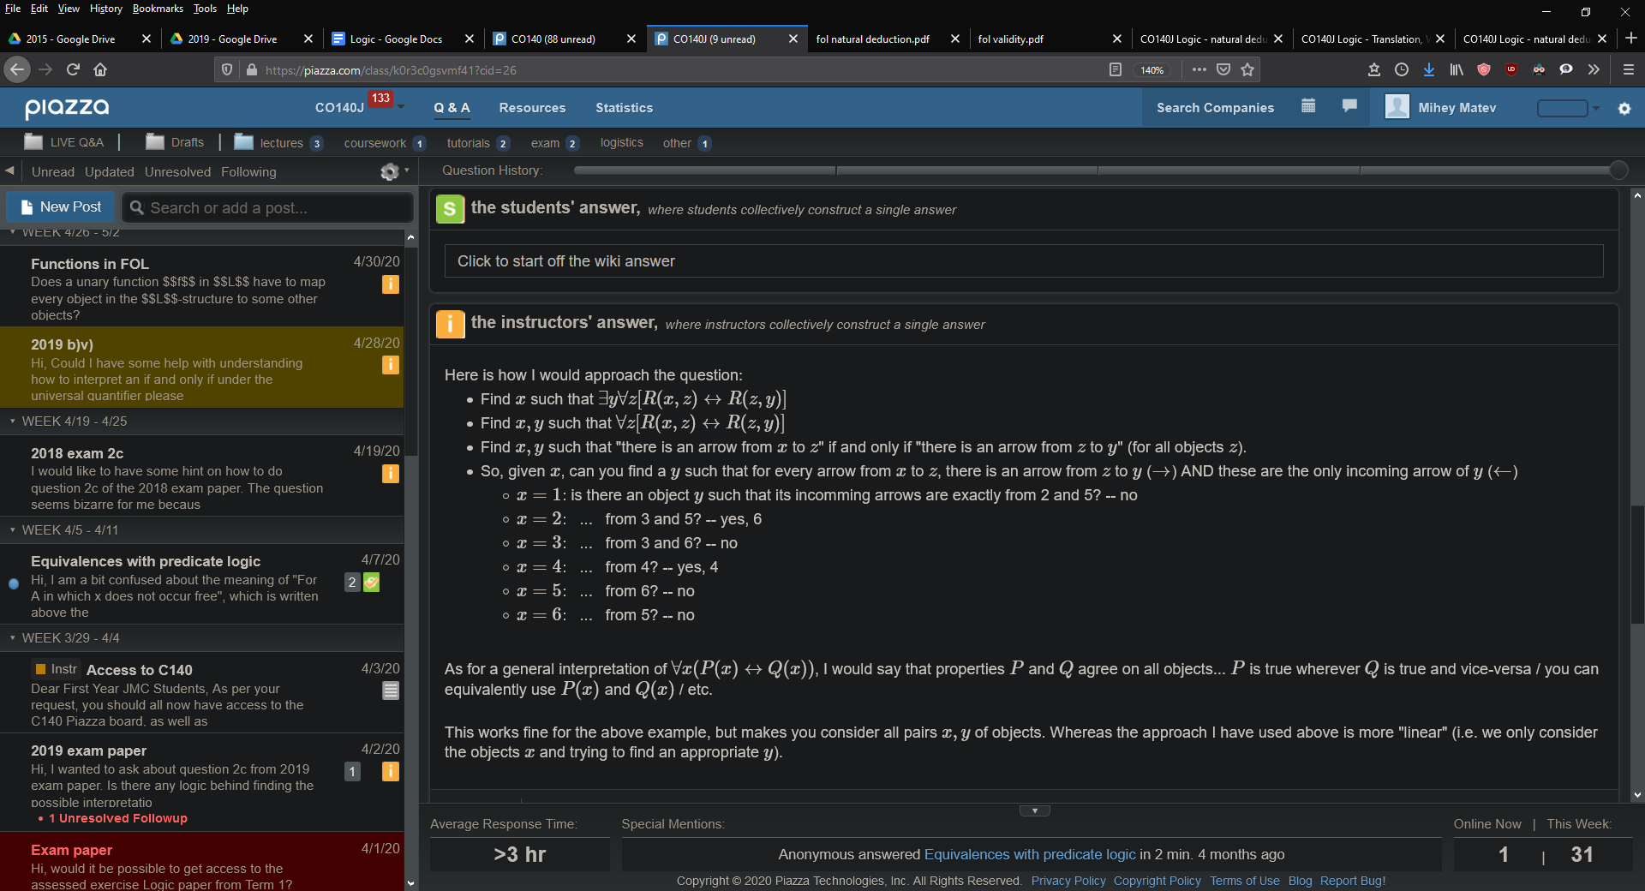

c) There are 3 interpretations of Q which make the statement valid.

Q can be true for [1, 2, 3, 4, 5, 6] or [1, 2, 4, 5] or [1,2,4,5,6] any reasonable property of these objects in M will do for Q. (I believe it is sufficient to give the stated li ts as an answer, rather than try to ivent a property based on them)

Explanation:

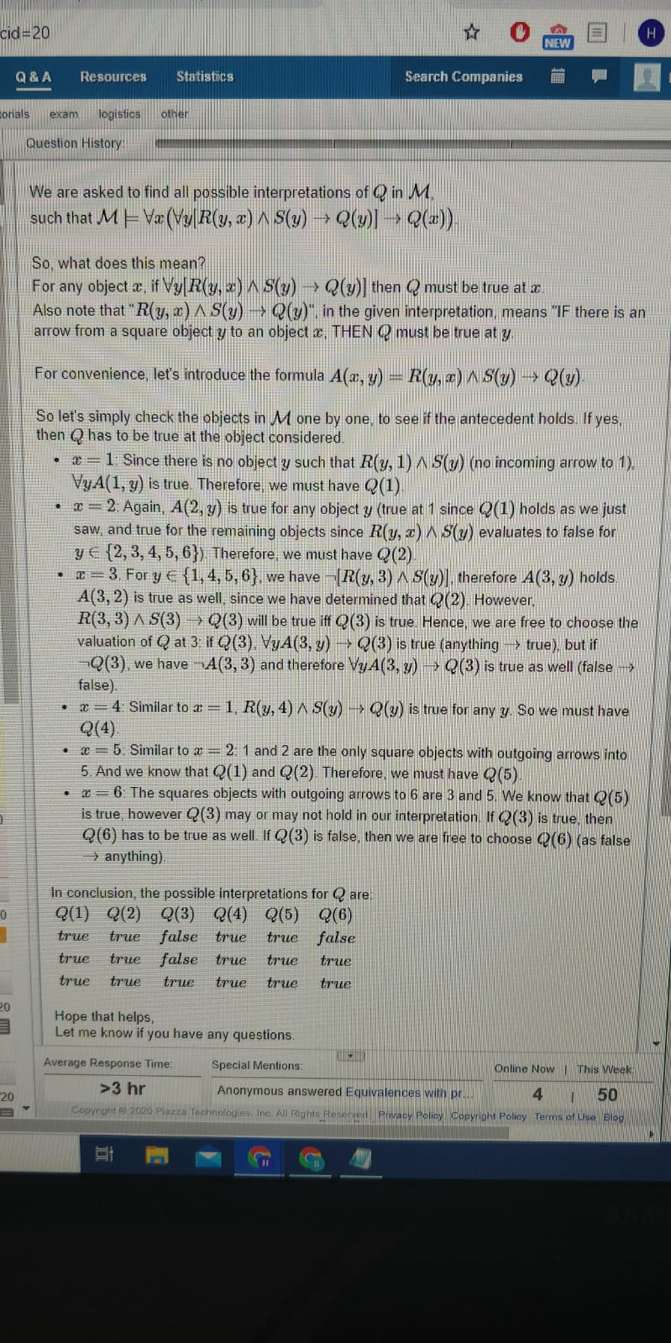

d)

